FORT COLLINS HIGH SCHOOL
3400 Lambkin Way
Fort Collins, CO 80525-5257
(970) 488-8021
(970) 488-8008 Fax
Lambkin Families, Alum and Community Members:

Academic and athletic success has always been a cornerstone of Fort Collins High School and the Lambkin Way. To continue on with the tradition of being the home of the champions we have found it necessary to come to you for help with upgrading our weight room.

Currently we have a weights class every period Monday through Friday of general education students affecting 578 kids. We also offer 27 sports throughout the school year with varying levels of competition from freshman teams to varsity, as well as a unified sports program with 4 additional teams. Our current school year athletic participation numbers are at 613 with spring sports still coming. Our 2022/2023 numbers including unified athletes was 986 students! We tell you all of this so you know that your contribution would be far reaching and directly impact hundreds of Lambkins each and every day.

Why? While it’s impossible to put these in an order of importance, one of our main concerns as physical educators and coaches is the safety and well-being of our students. Being able to update our equipment will increase safety as outdated equipment can pose safety risks for student-athletes. Our current weight room equipment was last updated in 2003 while many machines are even older than that. As with anything the technologies and functionality of the equipment has changed since that time. Updated equipment can also help with injury prevention and rehabilitation keeping student athletes in competition as well as improved student athlete performance. We feel strongly that strength, speed and conditioning greatly improve athletic performance. In return, the overall success of athletic programs helps to build a strong school culture. Additionally, it is widely recognized that the health benefits for all students that partake in a weightlifting regimen are far reaching. Not only physical, but also emotional and social which are at the forefront of many of our students' lives every day. Finally, when we look around town at the other high school’s weight rooms we are quite behind. To have equitable access for our students we want to provide them a space that they can not only work hard in to achieve their goals but take pride in!

How can you help? There are many ways for you to help with our campaign. We have a very lofty goal of $250,000. This would allow us to completely redo the entire space, including flooring. Please see the additional pages if you wish to see what this could look like.
- Make a financial donation. All donations will be tax deductible and receive a receipt.
Click here to go to school pay to directly donate into the weight room fund. There is a small fee associated with this. If you wish to donate via a check please make it out to Fort Collins High School and write: weight room on the memo line. You can drop it off or mail it to:
Fort Collins High School
Attn: Liz Delap/weight room fund
- Lambkin Way Fort Collins, CO 80525
- Share our needs with others in the community or your family or social circle who may be willing to help.
- Send additional fundraising ideas or get involved and join our athletic booster club!

Thanks so much for taking the time to review this! If you have further questions, please reach out to Lindsey Blahauvietz via email at lindseyb@psdschools.org
Our Current Weight Room

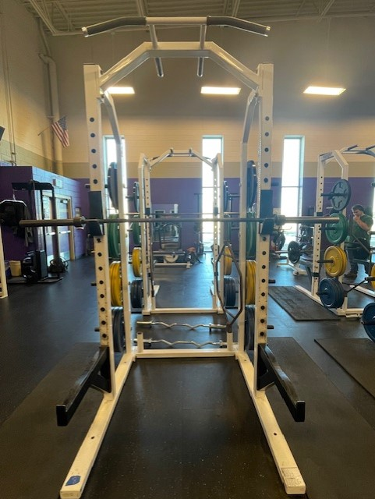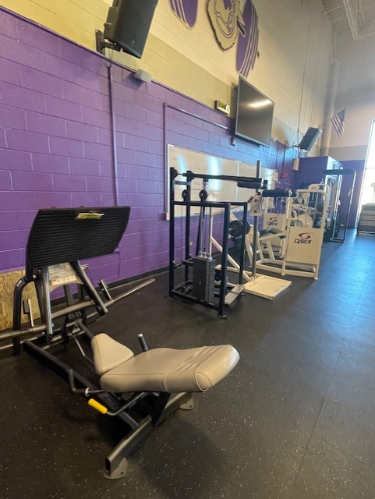

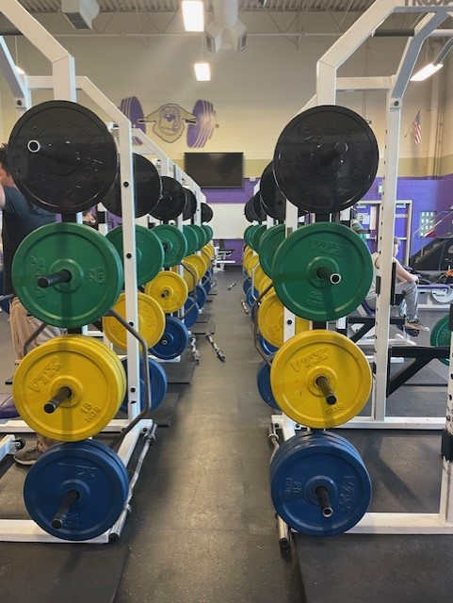

Current Weight Rooms at other PSD High Schools

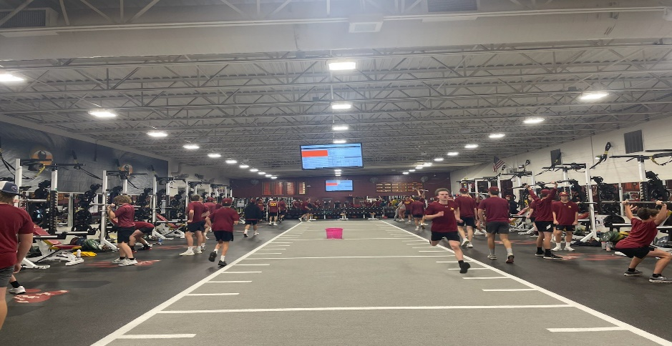

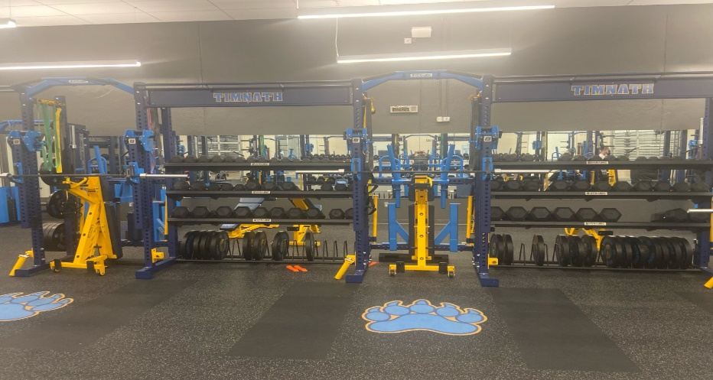

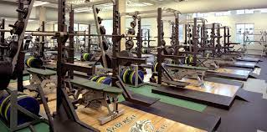

Potential Renderings of FCHS Weight Room

