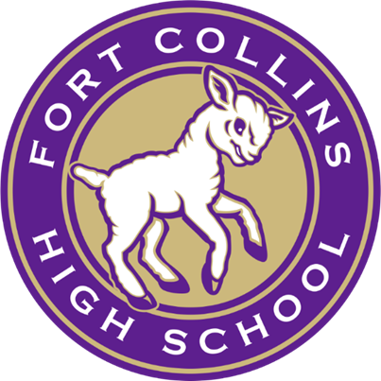
FCHS Scholarships
One application.

The following is the comprehensive list of scholarships included in the FCHS Scholarship Application. Some scholarships are only offered to certain high schools. Any scholarships with an asterisk are for in-state Colorado colleges and universities. If you do not plan to attend a Colorado post-secondary institution, you do not meet the criteria.

BRIAN BALL MEMORIAL SCHOLARSHIP (FCHS only)
Criteria:
● Must be a graduating FCHS senior
● Involved in school and community activities
● Planning to study in a helping profession (no engineering or computer based majors)

Amount: $500 scholarship

DOC AND MARIAN PIKE "ALL WAYS" A LAMBKIN MEMORIAL - ARTS SCHOLARSHIP (FCHS only)*
Criteria:
- Recipient will have achieved a balance of excellence in Academics and Activities
- 3.0 GPA or higher
- Must have demonstrated outstanding participation in either 2 of the arts (theatre, music or art) and 1 co-curricular activity or 2 co-curricular and 1 of the arts (theatre, music or art) at FCHS
- Must demonstrate attributes admired, respected and demonstrated by Doc Pike: honesty, integrity, hard work, compassion, dedication, humor, respect for diversity and school spirit
- Must have made a positive difference at Fort Collins High School through leadership, involvement and influence
- Attendance at an in-state college is required of the recipient

Amount: $1,000 non-renewable scholarship

DOC AND MARIAN "ALL WAYS" A LAMBKIN MEMORIAL SCHOLARSHIP (FCHS only)*

Criteria:
- Recipient will have achieved a balance of excellence in Athletics, Academics, and Activities
- 3.0 GPA or higher
- Must have demonstrated outstanding participation in either 2 sports and 1 co-curricular activity or 2 co-curricular activities and 1 sport at FCHS
- Must demonstrate attributes admired, respected and demonstrated by Doc Pike: honesty, integrity, hard work, compassion, dedication, humor, respect for diversity, and school spirit
- Must have made a positive difference at Fort Collins High School through leadership, involvement, and influence
- Attendance at an in-state college is required of the recipient

Amount: $1,000 non-renewable scholarship

LOCAL CHANGE FOUNDATION AVID SCHOLARSHIP (FCHS only)

Criteria:
High school seniors at Fort Collins High School who participate in the Advancement Via Individual
Determination (AVID) Program. The AVID program prepares students for college eligibility and success by developing writing, inquiry, collaboration, organization and reading skills. Typically, students participating in elective AVID classes are the first in their families to attend college, and many are from low-income or minority families. Only AVID students at Fort Collins High School are able to apply.

Amount: $2,000 scholarship

MEGAN MARIE NUTTALL MCGREW MEMORIAL (FCHS only)

Criteria:
- Play a band instrument and intend to participate in a college music program (need not major in music)
- Financial need considered, but not a determining factor
- 3.0 GPA or higher

Additional Statement Prompt:
In 500 words or less, what role does music play in your life?

Amount: $500 scholarship

