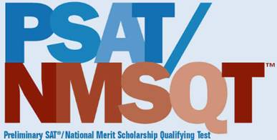
Fort Collins High School PSAT/NMSQT Test Date:
Thursday, October 26, 2023, 8:30 am in FCHS Gym 1

Registration for the PSAT/NMSQT is open beginning September 1, 2023 and ending on September 25, 2023. Students should register for this optional PSAT exam if they are seeking National Merit Scholarship recognition. This is the ONLY PSAT exam that will qualify Juniors for the National Merit Scholarship. Please note that all juniors and sophomores will automatically be registered for and have the opportunity to take the state-required Colorado SAT/PSAT in April 2024.

The window for the online exam registration will begin on Friday, September 1 and will end on September 25, 2023 at 11:59 pm. Tests are limited so please register as soon as possible. If you have been approved for testing accommodation through the College Board and plan to take the PSAT-NMSQT, please contact Anna Morris (amorris@psdschools.org) or Justin Stephens (jstephen@psdschools.org) by September 5 so we can order the appropriate exam.

This registration will take a few minutes and can be completed from any computer with internet access. We strongly recommend that students and their parent/guardian are both present while registering to ensure that the registration process is complete and to ensure a test will be available during the national testing window. To register, students need to click here: www.TotalRegistration.net/PSAT/060590. To complete registration, students must answer the required questions. Registration is not complete until students have printed the pdf of the confirmation page that is provided at the end.

The cost of the PSAT/NMSQT is $20.00 and is paid in person through Ms. Liz Delap (FCHS Bookkeeper) located just outside the main office. Accepted methods of payment: cash, check, or credit card. Ms. Delap can be contacted at 970-488-8019 or edelap@psdschools.org.

The PSAT/NMSQT will be administered in the FCHS Gym 1 on Thursday, October 26, 2023, promptly at 9:00 am. Check-in begins at 8:30 am. Students need to provide their own No. 2 pencils and a calculator. No cell phones or backpacks are allowed in the testing room.

Important dates for the registration process:
- Friday, September 1, 2023 - Registration Begins
- Monday, September 25, 2023 at 11:59 pm - Registration Ends
- Friday, October 20, 2023 - Registrations that have not been paid for may be canceled and students on the waiting list will have the opportunity to purchase an exam.

